
News Release

FOR IMMEDIATE RELEASE
Contacts: | Editorial contacts:  Heiko Hespen or Nick Foot  Billings Europe  Tel: +44-1491-636 393  Fax: +44-1491-636 383  heiko.hespen@billings-europe.com | Pavlina Dvorakova  Marcom Coordinator  Tyco Electronics UK  Tel: +44 (0)1376 509 528  pavlina.dvorakova@tycoelectronics.com Sales: 0870 870 7500
NEW HIGH QUALITY RING TYPE CURRENT TRANSFORMERS SAVE INSTALLATION TIME
WITHAM – May 10, 2007 – A range of high quality ring type Crompton Instruments Current Transformers with one metre flying leads, suitable for primary currents from 60 up to 2500A with 5A secondaries, has recently been released by Tyco Electronics.

The cost-effective and versatile tape wound DB series current transformers are easily and quickly installed where conventional foot/busbar mount devices are not practical due to space or location. Long flying leads can easily be terminated wherever convenient and provide a consistent and versatile connection to any measuring/indicating equipment in applications such as switch gear, distribution systems, generator sets and control panels.

Featuring Class 3 accuracy and Class E insulation, DB series current transformers aren’t liable to vibration issues when fitted in an alternator box and can withstand an overload of 1.2 times rated current continuously. Designed for an operating temperature range from +20 up to +70 degrees Celsius, the devices are compliant with IEC44-1 EN60044-1.

Tyco Electronics, the TE logo, AMP, Axicom, Dulmison, Raychem, SIMEL, Bowthorpe EMP, Crompton Instruments, Dorman Smith are trademarks.
Crompton is a trademark of Crompton Parkinson Ltd., and used by Tyco Electronics under licence.

About Tyco Electronics
Tyco Electronics, currently a business segment of Tyco International Ltd., is a leading global provider of engineered electronic components, network solutions and wireless systems, with 2006 sales of US$12.7 billion to customers in 150 countries. Tyco Electronics designs, manufactures and markets products for customers in industries from automotive, appliances and aerospace and defense to telecommunications, computers and consumer electronics. With over 8,000 engineers and worldwide manufacturing, sales and customer service capabilities, Tyco Electronics’ commitment is its customers’ advantage. More information on Tyco Electronics can be found at www.tycoelectronics.com.
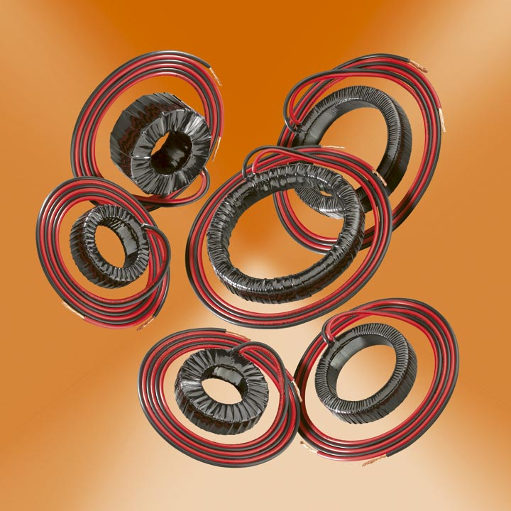
About Tyco Electronics – Energy Division
The Energy Division of Tyco Electronics is a global manufacturer of products and systems for the electrical power industry. Its products are extensively employed by power utilities and equipment manufacturers, in rail transport systems and in industry around the world.
The Energy Division of Tyco Electronics offers a wide product range from brands such as AMP, Axicom, Dulmison, Raychem, SIMEL, Bowthorpe EMP, Crompton Instruments, Dorman Smith, including cable accessories, connectors and fittings, switching and power management devices, lighting protectors, surge arresters and insulators.
http//:energy.tycoelectronics.com

